**Task2-Gemini**

**Inline, Internal, and External CSS**

CSS (Cascading Style Sheets) can be applied to HTML elements in three primary ways: inline, internal, and external. Each method has its own advantages and disadvantages, depending on the specific use case.

**Inline CSS**

* **Definition:** Styles are directly applied to individual HTML elements using the style attribute.
* **Example:**

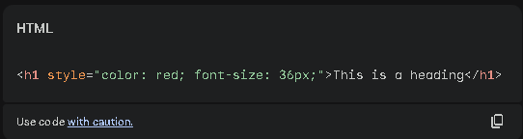

* **Advantages:**
  + Provides immediate styling for specific elements.
  + Can be useful for quick adjustments or prototyping.
* **Disadvantages:**
  + Makes HTML code less readable and maintainable.
  + Difficult to reuse styles across multiple elements.
  + Not suitable for large-scale styling.

**Internal CSS**

* **Definition:** Styles are defined within the <head> section of an HTML document using the <style> tag.
* **Example:**

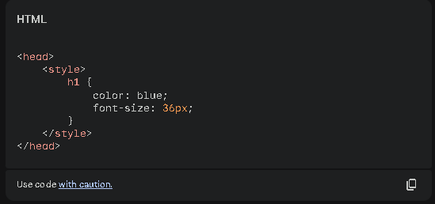

* **Advantages:**
  + Keeps styles within the same document.
  + Easier to manage than inline styles.
  + Suitable for small-scale styling.
* **Disadvantages:**
  + Not ideal for large or complex stylesheets.
  + Can clutter HTML code.
  + Difficult to reuse styles across multiple pages.

**External CSS**

* **Definition:** Styles are defined in a separate .css file and linked to the HTML document using the <link> tag.
* **Example:**

**Result :**

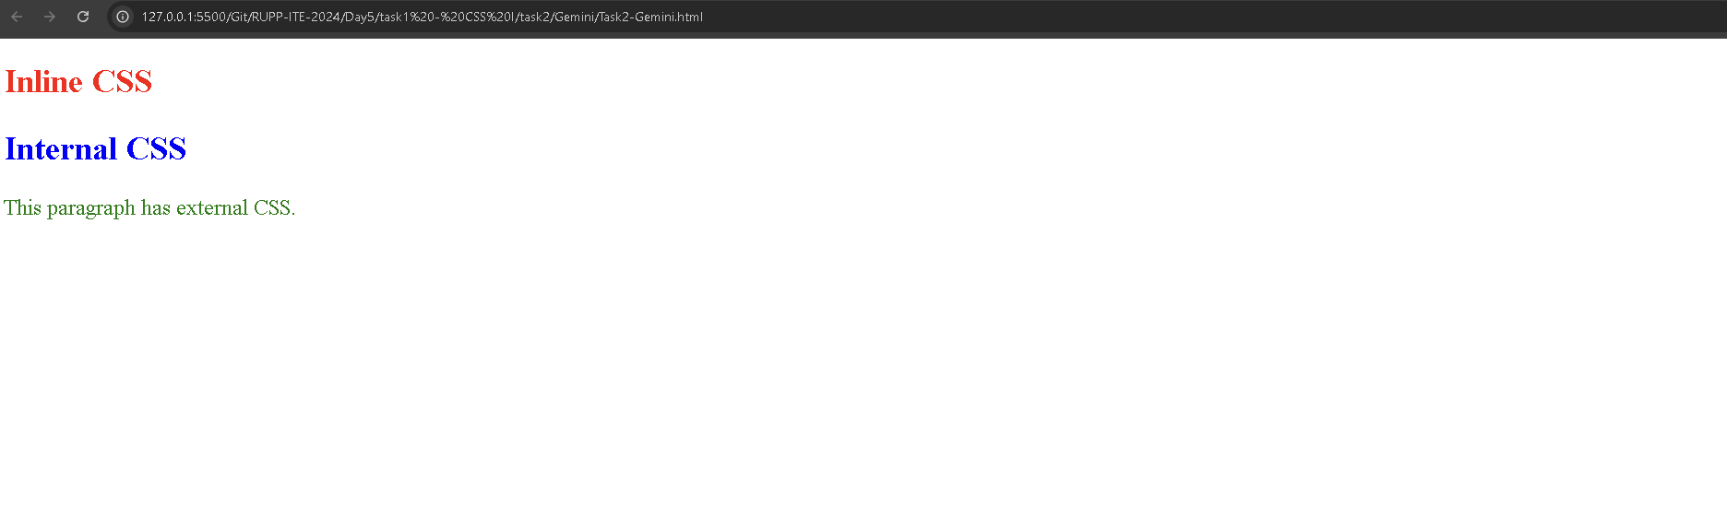

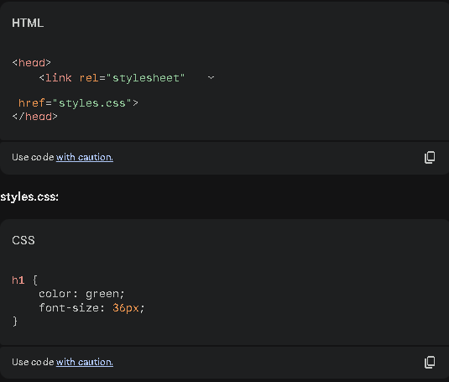

• **Advantages:**

* Separates content (HTML) from presentation (CSS).
* Improves code organization and maintainability.
* Reusable across multiple HTML pages.
* Ideal for large or complex stylesheets.

• **Disadvantages:**

* Requires additional HTTP requests to load the CSS file.
* Can slightly increase page load time.

**Demonstrating All Three Methods :**

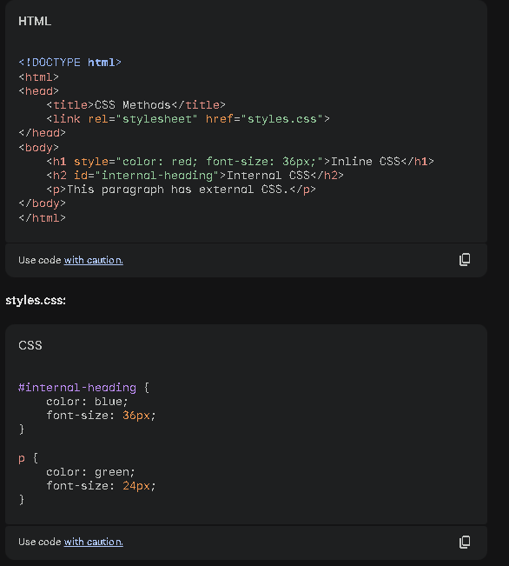

In this example:

* The first heading uses inline CSS to set its color and font size.
* The second heading uses internal CSS to set its properties within the <head> section.
* The paragraph uses external CSS defined in the styles.css file.

**Choosing the Right Method:**

* **Inline CSS:** Use for quick styling adjustments or prototyping, but avoid for large-scale styling.
* **Internal CSS:** Use for small-scale styling within a single HTML document.
* **External CSS:** Use for large, complex stylesheets that need to be reused across multiple pages.